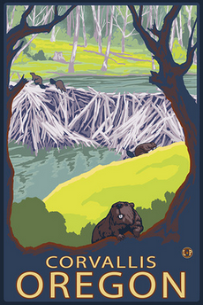
Western Region
American Association for Agricultural Education

September 14-16, 2015
Corvallis, OR

Call for Preparation and Submission of Papers

Manuscript Submission Format:
- Prepare manuscripts in MS Word format.
- Use Times Roman or Times New Roman 12-point font.
- Set all margins at one inch.
- Do not put your name or other identifying information on/in manuscript. For example use [university] instead of your university’s name.
- Single-space the manuscript; but double-space between paragraphs, heading and text, table and text, etc.
- Center the bolded title of submission at the top of the first page; capitalize only first letters of words in the title.
- Type the abstract (maximum word count of 200) in italics immediately after the title of the manuscript.
- Start the body of your manuscript immediately following the abstract (with bolded, centered heading as suggested below).
- Use as suggested sections the following: Introduction/Theoretical Framework, Purpose(s)/Objective(s), Methods/Procedures, Results/Findings, Conclusions/ Recommendations/Implications, References.
- Use the “Table” function command of MS Word to prepare tables rather than tabs and spaces.
- Place Tables/Figures within the body of the paper “shortly” after their first mention in text.
- Limit your manuscript to a maximum of 12 pages in length including all tables/figures but excluding references.
- Use “insert, page numbers” command of MS Word to number all manuscript pages, including the first page; center number at bottom of each page. Do not use other footers, headers, or footnotes.
- Follow manuscript style guidelines as specified by the Publication Manual of the American Psychological Associate (6th ed.), except as modified above. Per the manual, italicize the names of journals, statistical symbols, titles of tables, etc. Do not use the underline feature in the above areas. Furthermore, turn off all hyperlinks of URL references.

Submission Procedures:
Manuscripts must be submitted no later than 11:59 p.m. (Central Time) on Monday, June 1, 2015
- Submit manuscript via FastTrack™ at http://aaae.expressacademic.org/login.php .
- If you are not a registered FastTrack™ user, you must create an account first.
- Submit an electronic file in MS Word of the completed manuscript.
- In the FastTrack™ submission process, be sure to provide the following information:
- Title: Provide complete manuscript title
- Author(s): List name of lead author and all co-authors
- Document type: Select “Western Region”
- Document topic(s): Indicate “Research Methodology” [Historical, Mixed Methods, Philosophical, Qualitative, or Quantitative]. Additionally, indicate “Content Focus” most closely corresponding with the manuscript (i.e., the National Research Agenda topic).
- Document file: Attach the manuscript file and click “Submit document”

If you have any questions about submitting a manuscript, contact Misty Lambert (misty.lambert@oregonstate.edu ) or Jonathan Velez (jonathan.velez@oregonstate.edu ).

